**University of Petroleum and Energy Studies**

School of Computer Science

Department of Cybernetics



**Graphics & Animation Tools**

**VIVA-2 ASSIGNMENT**

**(Session: 2020-2021)**

Course: B. Tech with Specialization in Open Source and Open Standards

Batch: 2017-2021

Semester: VIIth

**Submitted By: -**

Nikhil Mishra

Roll No: R100217043

SAP ID: 500062584

**Submitted To: -**

Dr. Durgansh Sharma

Assistant Professor

Department of Cybernetics

**1) Aim:** Create any Mountain Range with Snowfall over it using GIMP.

**Steps followed**:

1. Open GIMP.
2. Inside gimp, create a new layer with white background (1056x701 px).
3. Open an image of mountain as layers in GIMP and create a new transparent layer to draw boundaries.
4. Use the ‘Paths tool’ over the image and start selection boundaries and layout of the image.
5. After selection of layout/ boundaries, go to ‘Select’, choose ‘From Path’ option and your path will be selected.
6. After path is selected click on ‘bucket fill tool’ from the toolbar and colour the mountain with your desired colour.
7. Repeat step 3,4,5 for creating the grass, river and sky of the scene.
8. Structure of mountain scene is complete.
9. Use your creativity to style the snow cap and when you feel it’s good, then place is at the top of mountain range.
10. For adding snowfall effect, add a new layer of black colour over all the layers and set the photo effect from normal to screen.
11. Go to Filters -> Noise -> RGB Noise and then press ‘OK’, this will add some noise to the image and make it translucent.
12. Again, Go to Filters -> Blur -> Pixelize and then press ‘OK’, this will make noise effect pixelized.
13. Then, Go to Filters -> Blur -> Motion Blur and then press ‘OK’.
14. After completing above steps, Go to Colors -> Levels and adjust the white and black input levels till you find pixelated snow effect over your image.
15. Your image is complete export it as .png and save it.

**Output:**

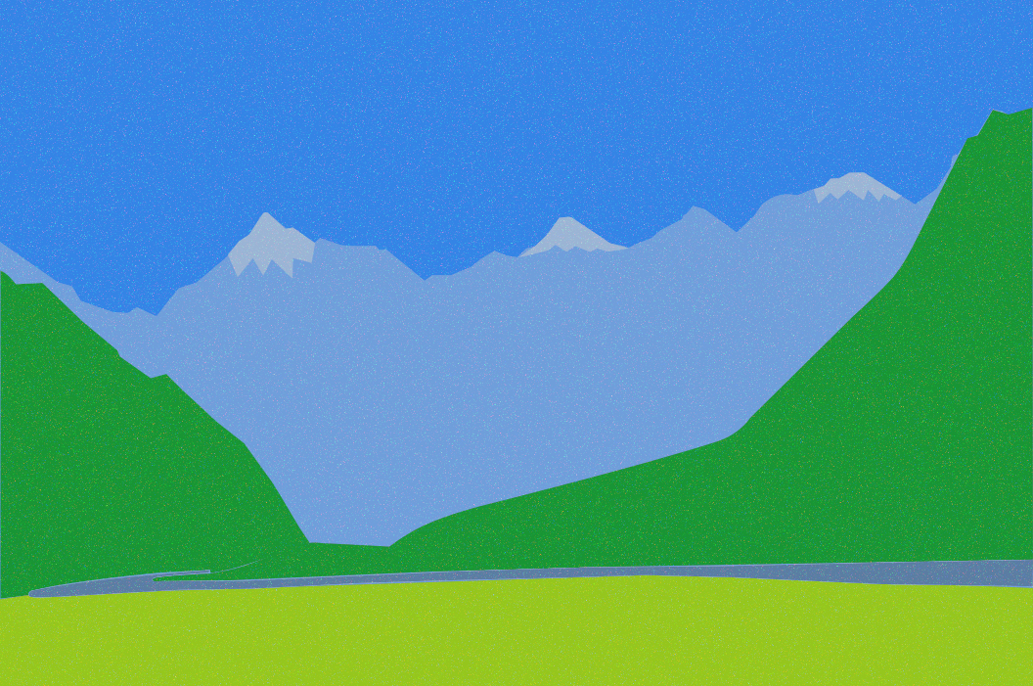

**2) Aim:** Create any City or Skyscraper using Blender.

**Steps followed:**

1. Open Blender, and clear everything from the interface which are already there.
2. Create a new project and clear out the screen, i.e., remove the default cube.
3. Start with adding a plane to act as the base.
4. Now, add a cube and scale it to look like a cuboid (main structure of the building).
5. Now, take a plane and scale it and position it on one of the sides of the base cube (to represent windows).
6. Set the surface of the plane representing windows to Glass BSDF to give a glass like effect.
7. Add the plane representing windows as per the size of the base cube.
8. Do the same as in step 5 to all the sides of the cube.
9. Now choose a front side of the building, make another plane and scale and fix it at the bottom of the base cube representing the door of the building.
10. Fill colours in all the shapes as per your choice.

**Output:**

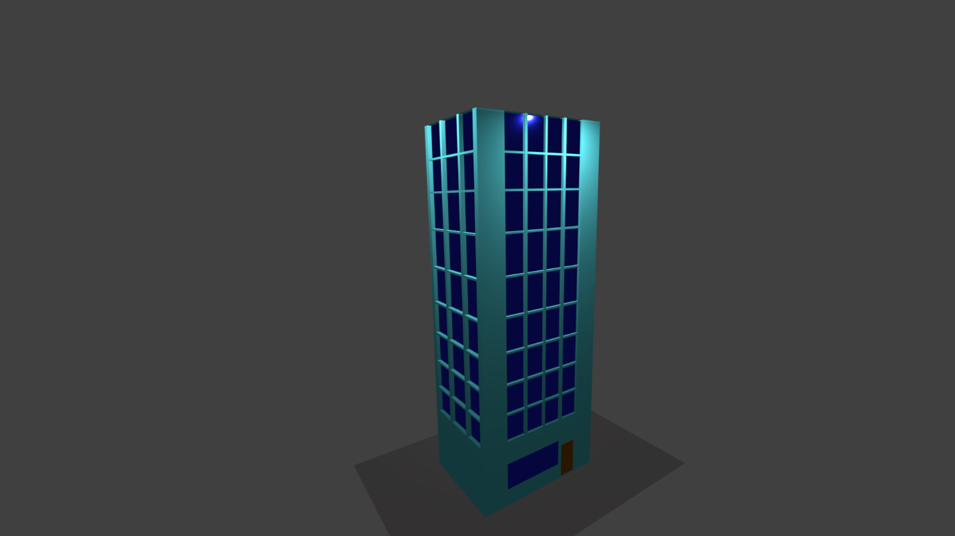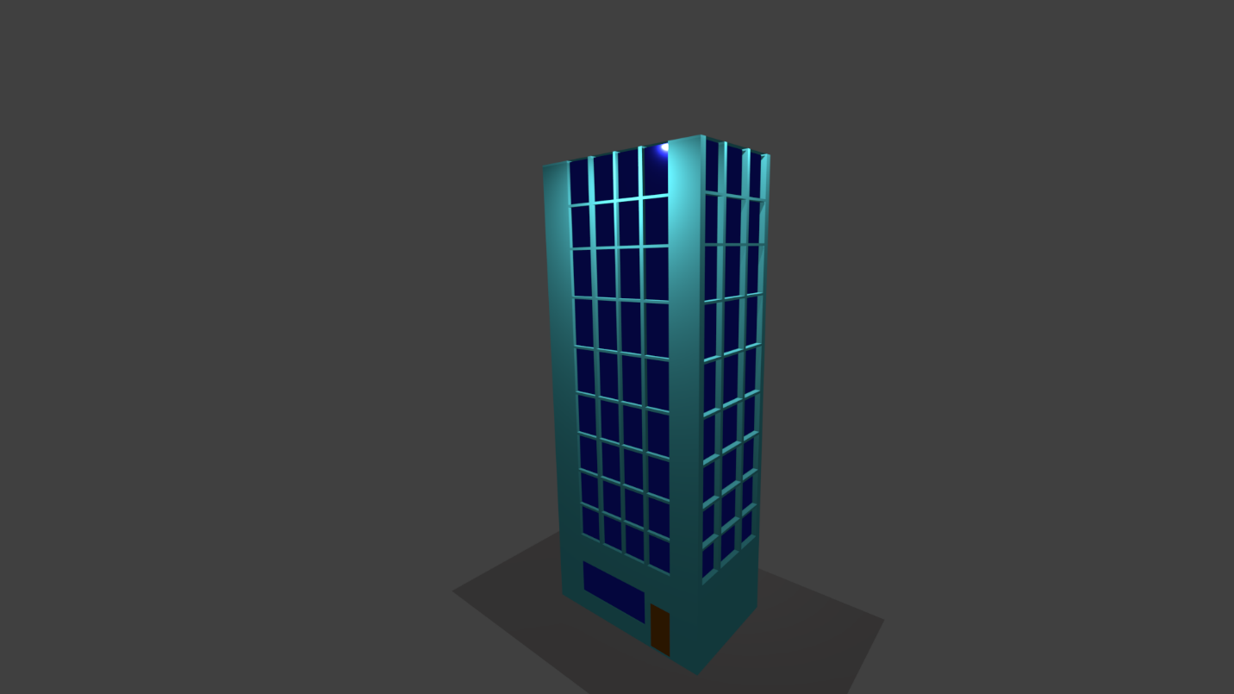

**Drive Link:** <https://drive.google.com/drive/folders/18C0VtIAk-awUy3Axst3degZLR7YdXza2?usp=sharing>